The Changing Face of Organized Crime in the GTA:
Bikers, Mobsters, Millennials and Cartels
Toronto Star reporter and author, Peter Edwards discusses how the Internet is changing the face of organized crime and how this relates to all established organized crime groups. He will also explain how domestic abuse has a ripple effect of often pushing boys into gangs when they reach their teens, and will talk about how Canadian millennials are interacting with Mexican drug cartels.
Peter Edwards is the award-winning author of sixteen books, a producer at Top Left Entertainment and organized crime reporter at The Toronto Star. He was an executive producer on the Netflix/ CITY-TV mini-series Bad Blood, produced by New Metric Media. His book, One Dead Indian, was developed by Sienna Films into Gemini Award winning movie for CTV and aptn.
Monday November 25th, 7 - 8 pm
Toronto Reference Library
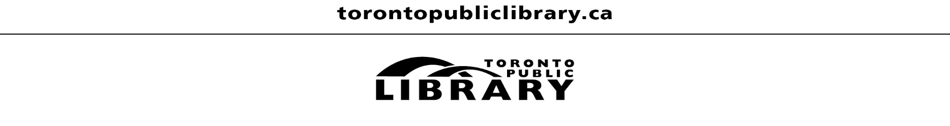
Beeton Hall - Main Floor
All are welcome. No registration required.

